Maru-Dry Fruits

|  |  |  |
| --- | --- | --- |
| Supervisor | Sir Zaman | |
| Batch | 2202e | |
| Group | Maru-Dry Fruits | |
| Serial No. | Enrollment  Number | Student  Name |
| 1 | Student1364329 | Muhammad Ameen |
| 2 | Student1365962 | Muhammad Mustafa |
| 3 | Student1366017 | Noman |
| 4 | Student1366037 | Anus |

*Acknowledgment*

*First, we would like to express our special thanks to my teacher “Sir Zaman” who help us a lot to finalize the project in the given time duration, with valuable counseling & assistance For the accomplishment of this project.*

*Secondly, we would like to thanks the e-Project team at Aptech Head Office, who give us the opportunity to do this wonderful & interesting project about Maru-dry Fruits.*

*Following are the benefits of this project:*

* Re-enforcement of Skills happens in the experiential learning process.
* It gives you a lot of confidence to face an interview as you have worked on a project. You can explain virtually everything on the subject you have learnt.

*Synopsis*

Maru-Dry Fruits is very important Without the Benefits, we'd have a different Benefits of Dry Fruits.Maru-Dry Fruits is important because 250Grams, 500Grams, & 1KiloGrams with the Weight System

The most important feature of the Maru-Dry Fruits is its base in scientific fact and repeatable standards of Benefits.

The Dry Fruits has been adopted by almost in the world.

Dry fruits are very essentials for health in different diseases. Many countries have production of Dry fruits.

PROBLEM Statements

The dry fruits are rich in vitamins and proteins; they also boost immunity and

prevent lifestyle diseases such as cholesterol and diabetes. Most dry fruits are rich in

minerals, proteins, fiber and vitamins add to that they are tasty and delicious

too. Dry fruits are excellent and healthy substitute for daily snacks.

Maru dry fruits - a local shop in the market is pretty old and needs website for

advertising the products, providing information about them so as to attract more and

more customers

the work(briefly)

The name of project is Maru-Dry Fruits.

The software provides the customer various

Facilities. In this project we can easily

Maintain the detail of Dry Fruits Benefits.

It’s gives complete information of Dry Fruits.

. It’s name, our 7 main page For Maru-dry Fruits. We can see our detail & benefits before

Using website.

For example, any user can manually use this website for any kind of Dry Fruits and Benefits 250Grams 500Grams & 1kilogram.

Site map

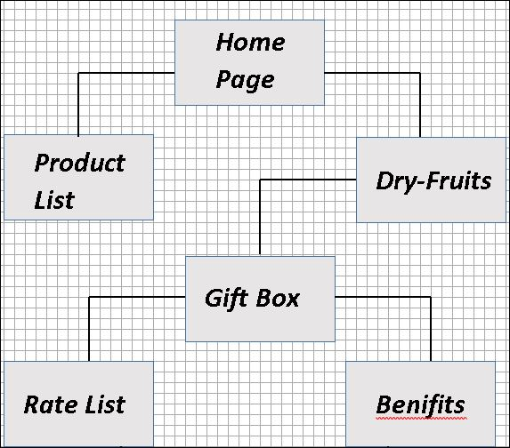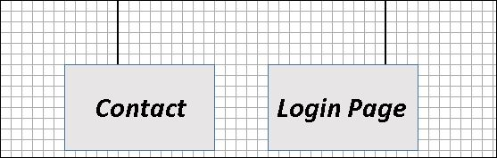

Wireframes

**LAYOUT**

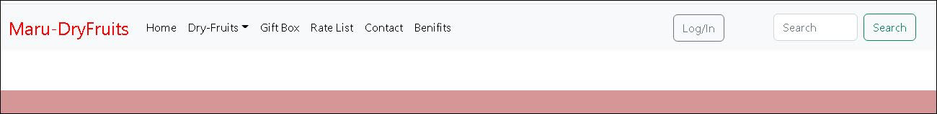

Bottom Layout

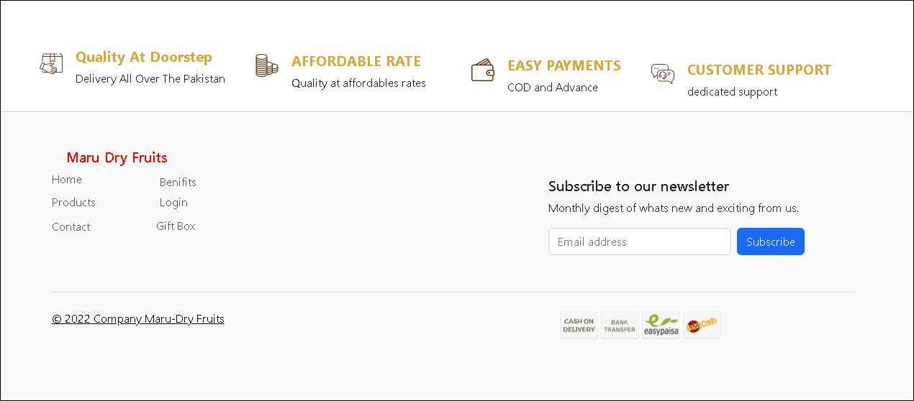

­­­­­­­­­­­­­­-­­­­



***Login Page***

***Contact***

***Benifits***

***Product List***

***Rate List***

***Gift Box***

***Dry-Fruits***

***Home Page***